Order Of Service

Singing: Psalm 119b—CW page 110

Reading: Psalm 18:7-15

Opening Hymn: TLH 648

Reading: I Corinthians 11:17-22

Request Hymn: CW Supplement 735

Reading: Mark 1:21-28

Sermon Hymn: TLH 605

Sermon Text: Luke 11:24-28

Unclean Spirits

Prayer

The Apostles’ Creed, TLH page 12

Holy Communion

The Lord's Prayer

The Blessing

Closing Hymn: TLH 46

* * * * * * * * * * *

Bible Study: Lambs: Tornado
Sheep: Philippians
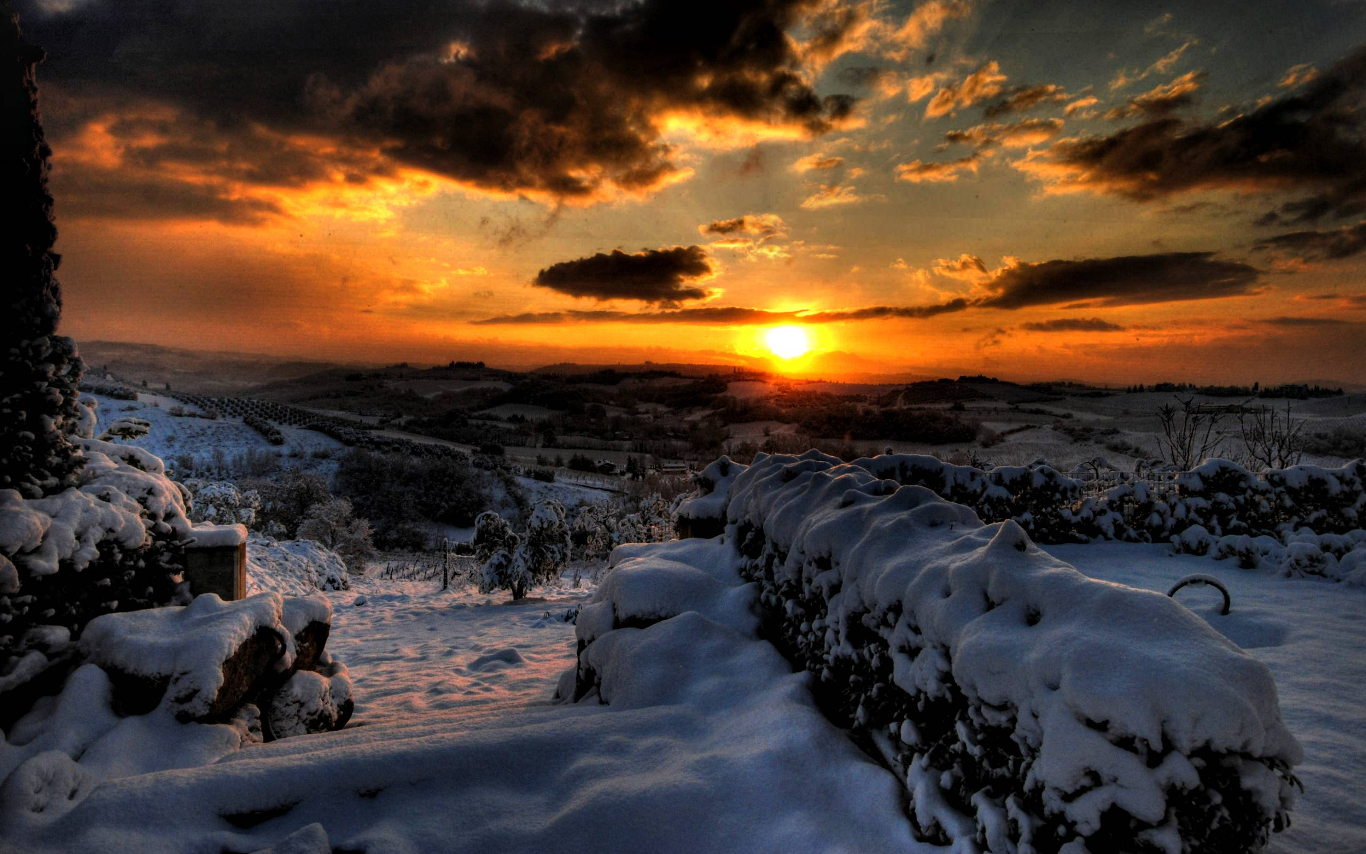

Approaching Night

Water
Of
Life

16 January 2022

W A T E R O F L I F E

Independent Christian Church—Conservative Lutheran Doctrine

Worship Service: 9:30 a.m. Bible Study: 10:45 a.m.

Larry Cooper, Pastor E-Mail address:
111 N. Ridge Road lcooper@wateroflife.cc
Coon Valley, WI 54623 Web Site:
www.wateroflife.cc

* * * * * * * * * * * * * * * * * * * * * * * * * * *

Sermon Text: Luke 11:24-28

Unclean Spirits

* * * * * * * * * * * * * * * * * * * * * * * * * * *

24 When the unclean spirit is gone out of a man, he walketh through dry places, seeking rest; and finding none, he saith, I will return unto my house whence I came out.
25 And when he cometh, he findeth it swept and garnished.
26 Then goeth he, and taketh to him seven other spirits more wicked than himself; and they enter in, and dwell there: and the last state of that man is worse than the first.
27 And it came to pass, as he spake these things, a certain woman of the company lifted up her voice, and said unto him, Blessed is the womb that bare thee, and the paps which thou hast sucked.
28 But he said, Yea rather, blessed are they that hear the word of God, and keep it.

44

